**A cura di Padre Secondo Brunelli crs**

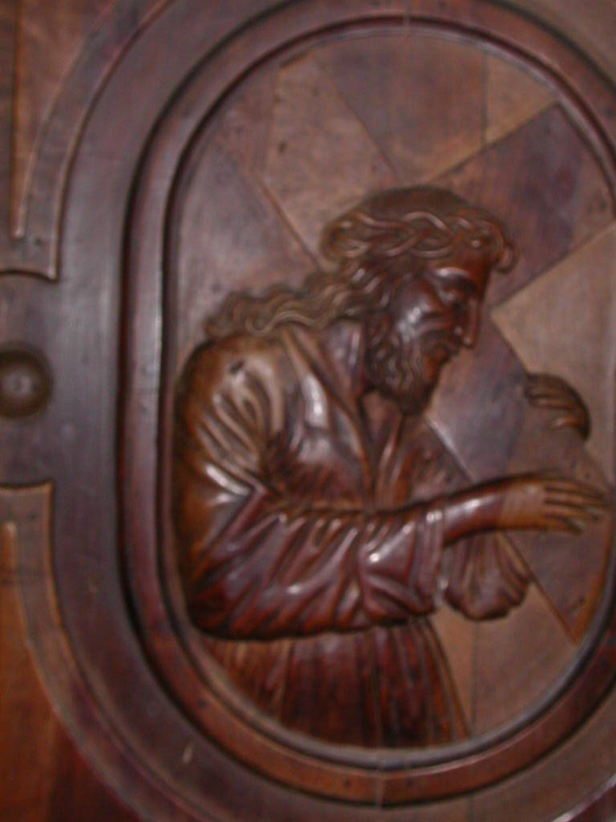

Gesù portracroce, Chiesa dei SS. Vittore e Corona, Feltre

**BELLUNO**

**RELIGIOSI SOMASCHI**

**1702-1786**

**Mestre 29.4.2017**

**1702**

|  |  |  |  |
| --- | --- | --- | --- |
| *P. Frugoni Carlo*  *Atti Verona* | *Fuggitivo da BL* | *22.4.1702* | *Da Seminario BL* |

**1710**

|  |  |  |  |
| --- | --- | --- | --- |
| *P. Pacata Taddeo*  *Atti Salute VE* | *Rettore a Belluno* | *6.12.1710* |  |

**1711**

|  |  |  |  |
| --- | --- | --- | --- |
| *P. Pacata*  *Atti Salute VE* | *Prep.to a Belluno* | *18.9.1711* |  |

**1712**

|  |  |  |  |
| --- | --- | --- | --- |
| *P. Pacata*  *Atti Salute VE* | *Rettore a Belluno* | *3.3.1712*  *19.5.1712* |  |

**1722**

|  |  |  |  |
| --- | --- | --- | --- |
| *Fr. Baldini Girolamo*  *Atti Salute VE* | *In Belluno* | *30.9.1722* | *+ 30.9.1722* |

**1724**

|  |  |  |  |
| --- | --- | --- | --- |
| *P. Bernuccio Filippo*  *Atti Salute VE* | *Era a Belluno* | *28.9.1724* |  |

**1725**

|  |  |  |  |
| --- | --- | --- | --- |
| *P. Amort Gaetano*  *Atti Feltre* |  | *10.6.1725* | *A Feltre* |
| *Ch. Orsezio Scipione*  *Atti Salute VE* |  | *7.2.1725* | *Alla Salute VE* |

**1727**

|  |  |  |  |  |
| --- | --- | --- | --- | --- |
| *Ch. Franzoni Antonio*  *Atti Salute VE* |  | *14.11.1727*  *15.11.1727* | | *Alla Salute VE* |
| *P. Laiolo G. Battista*  *Atti Feltre* | *Vestizione* | *8.7.1727*  *5.11.1727* | | *Sem. Belluno* |
| *P. Moiolo G.Battista*  *Atti Salute VE* | | *Prep.to Belluno* | *11.6.1727*  *15.11.1727* |  | | |

**1728**

|  |  |  |  |
| --- | --- | --- | --- |
| *P. Maiolo G.Battista*  *Atti Feltre* | *( o Laiolo?)* | *13.7.1728* | *Sem. Belluno* |

**1731**

|  |  |  |  |
| --- | --- | --- | --- |
| *P. Ambrosi Francesco*  *Atti Salute VE* | *In Belluno* | *6.1.1731* | *+ 6.1.1731* |

**1786**

|  |  |  |  |
| --- | --- | --- | --- |
| *Mons. Alcaini Sebastiano*  *Atti Salute VE* | *Vescovo* | *17.3.1786* | *A Belluno* |