**A cura di Padre Secondo Brunelli crs**

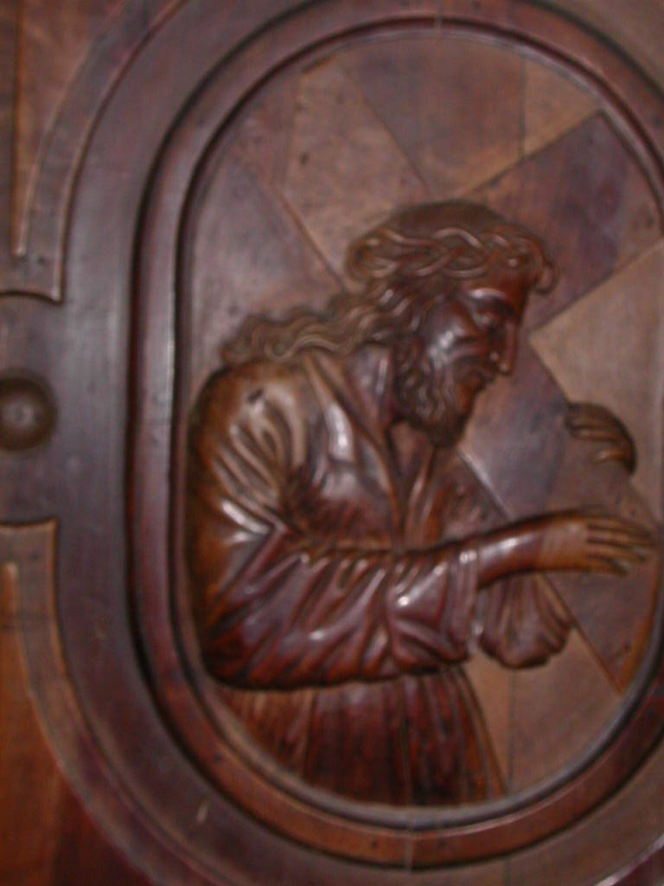

Gesù portacroce, Chiesa dei SS. Vittore Corona, Feltre

**MILANO COLOMBARA**

**RELIGIOSI SOMASCHI**

**1725-1767**

**Mestre 29.4.2017**

**Auctores, p. Alcaini Giovanni 29-5**

**Milano, S. Croce di Triulzo e la Colombara: orfanotrofio per studenti, pag. 388, ms**

**1725**

|  |  |  |  |
| --- | --- | --- | --- |
| *P. Bossi Marcanton*  *Atti Merateio* |  | *2.7.1725* | *A Merate* |
| *P. Strazza C. Giuseppe*  *Atti Somasca* |  | *19.5.1725* | *Da Somasca* |

**1728**

|  |  |  |  |
| --- | --- | --- | --- |
| *P. Strazza Carlo Giuseppe*  *Atti Somasca* |  | *29.10.1728* | *A Somasca* |

**1735**

|  |  |  |  |
| --- | --- | --- | --- |
| *P. Berretta G. Antonio (1)* |  | *5.1.1735* | ***+ 5.1.1735*** |

*(1) cfr. Riv. Congr. fasc. 1, 1925, P. Berretta Giovanni Antonio, pag. 19*

**1752**

|  |  |  |  |
| --- | --- | --- | --- |
| *P. Vailati Carlo Maria*  *Atti Vercelli* |  | *20.5.1752* | *Da Vercelli* |

**1754**

|  |  |  |  |
| --- | --- | --- | --- |
| *P. Vailati Carlo*  *Atti Salute* | *In Colombara MI* | *20.4.1754* | *+ 20.4.1754* |

**1755**

**1756**

|  |  |  |  |
| --- | --- | --- | --- |
| *P. Boldrini Giuseppe*  *ASMS MI* | *In Colombara* | *25.10.1756* |  |

**1759**

|  |  |  |  |
| --- | --- | --- | --- |
| *P. Assandri Ignazio*  *Atti SMS MI* | *Della Colombara MI* | *25.10.17539* |  |

**1762**

|  |  |  |  |
| --- | --- | --- | --- |
| *Fr. Onorio Dante Enr.*  *Atti SMS MI* |  | *26.9.1762* | *Da SM Segreta MI* |

**1763**

|  |  |  |  |
| --- | --- | --- | --- |
| *P. Azzimonti Ambrogio*  *Atti SMS MI* |  | *8.10.1763* | *Da SM Segreta MI* |

**1764**

**1765**

|  |  |  |  |
| --- | --- | --- | --- |
| *P. Azzimonti Ambrogio*  *Atti SMS MI* | *Colombara MI* | *25.10.1765* |  |