**A cura di Padre Secondo Brunelli crs**

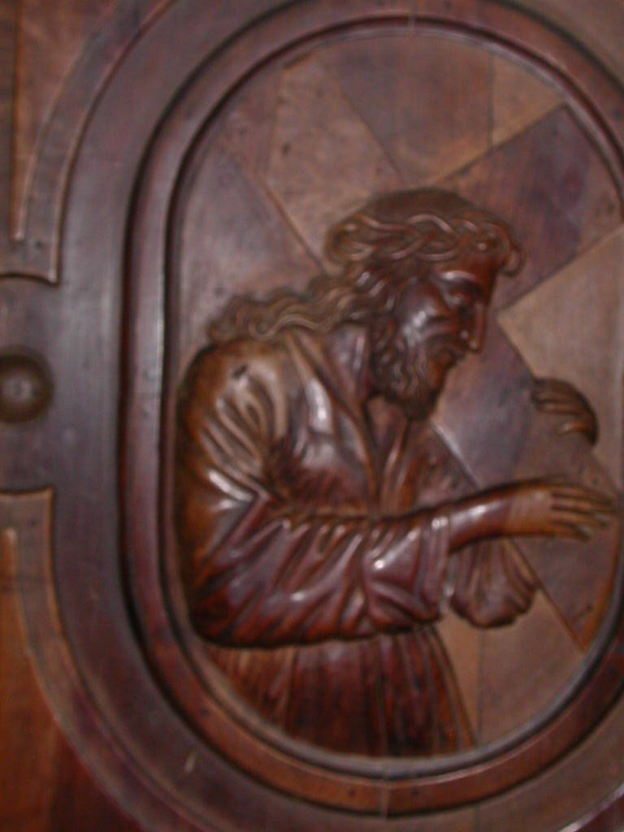

Gesù portracroce, Chiesa dei SS. Vittore e Corona, Feltre

**BELLUNO**

**RELIGIOSI SOMASCHI**

**1702-1786**

**Mestre 29.4.2017**

**1694**

|  |  |  |  |
| --- | --- | --- | --- |
| *Mons. Bembo* | *Vesovo di Belluno* | *1694* |  |
| *P. Cupilli Stefano* | *Direttore* | *1694* |  |

**1695**

|  |  |  |  |
| --- | --- | --- | --- |
| *P. Cupilli Stefano* | *Direttore* | *1695* |  |

**1696**

|  |  |  |  |
| --- | --- | --- | --- |
| *P. Cupilli Stefano* | *Direttore* | *1696* |  |

**1697**

|  |  |  |  |
| --- | --- | --- | --- |
| *P. Cupilli Stefano* | *Direttore* | *1697* |  |
| *P. Manara Michelang.* |  | *18.9.1797* | *Da Sem. Patr. VE* |

**1698**

|  |  |  |  |
| --- | --- | --- | --- |
| *P. Cupilli Stefano* | *Direttore* | *1698* | *Partenza* |
| *P. Manara Michelang.* | *Direttore* |  |  |

**1699**

|  |  |  |  |
| --- | --- | --- | --- |
| *P. Capoino Pietro* | *Maestro* | *1699* |  |
| *P. Manara Michelang.* | *Direttore* | *1699* |  |
| *P. Sorio Zaccaria* | *Maestro* | *1699* |  |
| *P. Valle* | *Assistente* | *1699* |  |
| *Fr. Xamini Giovanni* | *Assistente* | *1699* |  |

**1700**

|  |  |  |  |
| --- | --- | --- | --- |
| *P. Capoino Pietro* | *Maestro* | *1700* |  |
| *P. Sorio Zaccaria* | *Maestro* | *1700* |  |
| *Fr. Xami ni Giovanni* | *Assistente* | *1700* |  |

**1701**

|  |  |  |  |
| --- | --- | --- | --- |
| *P. Capoino Pietro* | *Maestro* | *1701* | ***+ 1701*** |
| *P. Sorio Zaccaria* | *Maestro* | *1701* |  |

**1702**

|  |  |  |  |
| --- | --- | --- | --- |
| *P. Frugoni Carlo*  *Atti Verona* | *Fuggitivo da BL* | *22.4.1702* | *Da Seminario BL* |
| *P. Sorio Zaccaria* | *Maestro* | *1702* |  |

**1703**

|  |  |  |  |
| --- | --- | --- | --- |
| *P. Sorio Zaccaria* | *Maestro* | *1703* |  |

**1704**

|  |  |  |  |
| --- | --- | --- | --- |
| *P. Sorio Zaccaria* | *Maestro* | *1704* |  |

**1705**

|  |  |  |  |
| --- | --- | --- | --- |
| *P. Sorio Zaccaria* | *Maestro* | *1705* |  |

**1706**

|  |  |  |  |
| --- | --- | --- | --- |
| *P. Ambrosi Francesco* | *Maestro* | *1706* |  |
| *P. Sorio Zaccaria* | *Maestro* | *1706* |  |

1707

|  |  |  |  |
| --- | --- | --- | --- |
| *P. Ambrosi Francesco* |  | *1707* |  |

**1708**

|  |  |  |  |
| --- | --- | --- | --- |
| *P. Ambrosi Francesco* |  | *1708* |  |

**1709**

|  |  |  |  |
| --- | --- | --- | --- |
| *P. Ambrosi Francesco* |  | *1709* |  |

**1710**

|  |  |  |  |
| --- | --- | --- | --- |
| *P. Ambrosi Francesco* |  | *1710* |  |
| *P. Pacata Taddeo*  *Atti Salute VE* | *Rettore a Belluno* | *6.12.1710* |  |

**1711**

|  |  |  |  |  |
| --- | --- | --- | --- | --- |
| *P. Ambrosi Francesco* |  | *1711* | |  |
| *P. Pacata Taddeo*  *Atti Salute VE* | | *Prep.to a Belluno* | *18.9.1711* |  | | |
| *P. Sorio Zaccaria* | | *Maestro* | *1711* |  | | |

**1712**

|  |  |  |  |
| --- | --- | --- | --- |
| *P. Ambrosi Francesco* |  | *1712* |  |
| *P. Pacata Taddeo*  *Atti Salute VE* | *Rettore a Belluno* | *3.3.1712*  *19.5.1712* |  |

**1713**

|  |  |  |  |
| --- | --- | --- | --- |
| *P. Ambrosi Francesco* |  | *1713* |  |
| *P. Manara Michelang.* | *Rettore* | *Gen. 1713* |  |
| *P. Pacata Taddeo* | *Rettore a Belluno* | *Gen. 1713* |  |

**1714**

|  |  |  |  |
| --- | --- | --- | --- |
| *P. Ambrosi Francesco* |  | *1714* |  |
| *P. Manara Michelang.* | *Rettore* | *1714* |  |

**1715**

|  |  |  |  |
| --- | --- | --- | --- |
| *P. Ambrosi Francesco* |  | *1715* |  |
| *P. Fontana Francesco* | *Rettore* | *1715* |  |
| *P. Manara Michelang.* | *Rettore* | *1715* |  |

**1716**

|  |  |  |  |
| --- | --- | --- | --- |
| *P. Ambrosi Francesco* |  | *1716* |  |
| *P. Fontana Francesco* | *Rettore* | *1716* |  |

**1717**

|  |  |  |  |
| --- | --- | --- | --- |
| *P. Ambrosi Francesco* |  | *1717* |  |
| *P. farei Francesco* | *rettorica* | *1717* |  |
| *P. Fontana Francesco* | *Rettore* | *1717* |  |
| *Fr.* |  |  |  |
| *Fr.* |  |  |  |

**1718**

|  |  |  |  |
| --- | --- | --- | --- |
| *P. Ambrosi Francesco* |  | *1718?* |  |
| *P. Fontana Francesco* | *Rettore* | *1718* |  |
| *P. Sorio Zaccaria* | *Rettore* | *1718* |  |
| *Fr.* |  |  |  |
| *Fr.* |  |  |  |

**1719**

|  |  |  |  |
| --- | --- | --- | --- |
| *P. Sorio Zaccaria* | *Rettore* | *1719* |  |

**Alla morte del Bembo i Somaschi sono licenziati in tronco.**

**1720**

|  |  |  |  |
| --- | --- | --- | --- |
| *P. Bertucci Zaccaria* |  | *21.7.1720* |  |
| *Mons. Bembo* | *Vescovo di Belluno* | *21.7.1729* | **+ 21.7.1720** |
| *P. Sorio Zaccaria* | *Rettore* | *1720* |  |

**Il 24.10.1721 i Somaschi sono riassunti**

**1721**

|  |  |  |  |
| --- | --- | --- | --- |
| *P. Sorio Zaccaria* | *Rettore* | *1721* |  |

**1722**

|  |  |  |  |
| --- | --- | --- | --- |
| *P. Ambrosi Francesco*  *Atti Feltre* | *Rettore* | *6.2.17221722* |  |
| *Fr. Baldini Girolamo*  *Atti Salute VE* | *In Belluno* | *30.9.1722* | *+ 30.9.1722* |

**1723**

|  |  |  |  |
| --- | --- | --- | --- |
| *P. Ambrosi Francesco* |  | *1723* |  |

**1724**

|  |  |  |  |
| --- | --- | --- | --- |
| *P. Ambrosi Francesco* |  | *1724* |  |
| *P. Bernuccio Filippo*  *Atti Salute VE* | *Era a Belluno* | *28.9.1724* |  |

**1725**

|  |  |  |  |
| --- | --- | --- | --- |
| *P. Ambrosi Francesco* |  | *1725* |  |
| *P. Amort Gaetano*  *Atti Feltre* |  | *10.6.1725* | *A Feltre* |
| *Ch. Orsezio Scipione*  *Atti Salute VE* |  | *7.2.1725* | *Alla Salute VE* |

**1726**

|  |  |  |  |
| --- | --- | --- | --- |
| *P. Ambrosi Francesco* |  | *1726* |  |

**1727**

|  |  |  |  |  |
| --- | --- | --- | --- | --- |
| *P. Ambrosi Francesco* |  | *1727* | |  |
| *Ch. Franzoni Antonio*  *Atti Salute VE* |  | *14.11.1727*  *15.11.1727* | | *Alla Salute VE* |
| *P. Laiolo G. Battista*  *Atti Feltre* | *Vestizione* | *8.7.1727*  *5.11.1727* | | *Sem. Belluno* |
| *P. Moiolo G.Battista*  *Atti Salute VE* | | *Prep.to Belluno* | *11.6.1727*  *15.11.1727* |  | | |

**1728**

|  |  |  |  |
| --- | --- | --- | --- |
| *P. Ambrosi Francesco* |  | *1728* |  |
| *P. Maiolo G.Battista*  *Atti Feltre* | *( o Laiolo?)* | *13.7.1728* | *Sem. Belluno* |

**1729**

|  |  |  |  |
| --- | --- | --- | --- |
| *P. Ambrosi Francesco* |  | *1729* |  |

**1730**

|  |  |  |  |
| --- | --- | --- | --- |
| *P. Ambrosi Francesco* |  | *1730* |  |

**1731**

|  |  |  |  |
| --- | --- | --- | --- |
| *P. Ambrosi Francesco*  *Atti Salute VE* | *In Belluno* | *6.1.1731* | *+ 6.1.1731* |

**1786**

|  |  |  |  |
| --- | --- | --- | --- |
| *Mons. Alcaini Sebastiano*  *Atti Salute VE* | *Vescovo* | *17.3.1786* | *A Belluno* |