**A cura di Padre Secondo Brunelli crs**

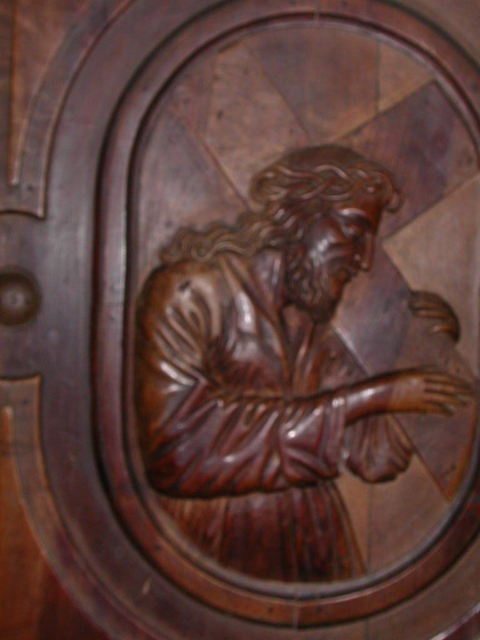

Gesù portacroce, Chiesa dei SS. Vittoe e Corona, Feltre

**ALESSANDRIA**

**RELIGIOSI SOMASCHI**

**Mestre 29.4.2017**

**1715**

|  |  |  |  |
| --- | --- | --- | --- |
| *P. Mezzera Gabrio*  *Atti Lugano* |  | *30.11.1715* | *A Lugano* |

**1716**

|  |  |  |  |
| --- | --- | --- | --- |
| *P. Gorio Giuseppe*  *Atti Merate* |  | *2.5.1716*  *31.5.1716* | *Da Merate* |

**1732**

|  |  |  |  |
| --- | --- | --- | --- |
| *Ch. Salomoni G. Battista*  *Atti S. Maiolo PV* |  | *29.10.1732* | *A S. maiolo PV* |

**1733**

|  |  |  |  |
| --- | --- | --- | --- |
| *Fr. Grossi Giannantonio*  *Atti S. Maiolo PV* | *Ospite* | *12.5.1733* | *Da S. Maiolo PV* |

**1734**

|  |  |  |  |
| --- | --- | --- | --- |
| *P. Garzia Carlo Giacinto*  *Atti Salute* | *In Alessandria* | *26.9.1734* | *+ 26.9.1734* |
| *P. Mainardi Francesco*  *Atti S. Maiolo PV* |  | *2.11.1734* | *Da S. Maiolo PV* |

**1736**

|  |  |  |  |
| --- | --- | --- | --- |
| *P. Airoldi Francesco*  *Atti S. Maiolo PV* |  | *14.9.1736* | *Da S. Maiolo PV* |

**1737**

|  |  |  |  |
| --- | --- | --- | --- |
| *Fr. Bettini Francesco*  *Atti S. Maiolo PV* |  | *31.5.1737* | *Da S. Maiolo PV* |

**1738**

|  |  |  |  |
| --- | --- | --- | --- |
| *Fr. Campi Andrea*  *Atti S. Maiolo PV* |  | *29.5.1738* | *Da S. Maiolo PV* |
| *P. Sassoli Pier Martire*  *Atti S. Maiolo PV* |  | *29.5.1738* | *Da S. Maiolo PV* |

**1739**

|  |  |  |  |
| --- | --- | --- | --- |
| *P. Zanoboni Defendente*  *Atti S. Maiolo PV* |  | *12.9.1739* | *Da S. Maiolo PV* |

**1740**

**1741**

|  |  |  |  |
| --- | --- | --- | --- |
| *Fr. Berva Francesco*  *Atti S. Maiolo PV* |  | *11.10.1741* | *Da S. Maiolo PV* |
| *P. Boldrini Giuseppe*  *Atti S. Maiolo PV* |  | *11.10.1741* | *Da S. Maiolo PV* |
| *P. Bolla Emilio*  *Atti S. Maiolo PV* |  | *31.7.1741* | *Da S. Maiolo PV* |
| *Fr. Campi Andrea*  *Atti S. Maiolo PV* |  | *18.5.1741* | *A S. Maiolo PV* |
| *Fr. Guanzati Francesco*  *Atti S. Maiolo PV* |  | *15.5.1741* | *Da S. Maiolo PV* |

**1742**

**1743**

**1744**

**1745**

|  |  |  |  |
| --- | --- | --- | --- |
| *P. Airoldi Francesco*  *Atti S. Maiolo PV* |  | *10.9.1745* | *A S. Maiolo PV* |
| *P. Calderari Michele*  *Atti S. Maiolo PV* |  | *10.6.1745* | *A S. Maiolo PV* |
| *P. Maffezzoli Carlo M.a*  *Atti S. Maiolo PV* |  | *5.6.1745* | *Da S. Maiolo PV* |

**1747**

|  |  |  |  |
| --- | --- | --- | --- |
| *P. Calderara Michele*  *Atti S. Maiolo PV* |  | *4.5.1747* | *Da S. Maiolo PV* |

**1749**

|  |  |  |  |
| --- | --- | --- | --- |
| *Fr. Biffignardi Antonio*  *Atti S. Maiolo PV* |  | *14.6.1749* | *Da S. Maiolo PV* |

**1750**

**1751**

|  |  |  |  |
| --- | --- | --- | --- |
| *P. Carbonara MicheleAtti S. Maiolo PV* |  | *15.5.1751*  *21.5.1751* | *A S. Maiolo PV* |
| *P. Salamoni Alberto*  *Atti S. Maiolo* |  | *17.5.1751* | *Da S. Maiolo PV* |

**1753**

|  |  |  |  |
| --- | --- | --- | --- |
| *P. Salomone Alberto*  *Atti Salute VE* | *In Alessandria* | *24.2.1753* | *+ 24.2.1753* |
| *P. Salomone Alberto*  *Atti S. Maiolo PV* | *In Alessandria*  *49 anni* | *14.2.1753* | *+ 4.2.1753* |

**1756**

|  |  |  |  |
| --- | --- | --- | --- |
| *Fr. Domenicone Sebast.*  *Atti S. Maiolo PV* |  | *13.9.1756* | *Da S. Maiolo PV* |

**1757**

|  |  |  |  |
| --- | --- | --- | --- |
| *Fr. Germano Alberto*  *Atti S. Maiolo PV* |  | *28.5.1757* | *A S. Maiolo PV* |

**1758**

**1759**

**1760**

|  |  |  |  |
| --- | --- | --- | --- |
| *P. Battanoli Francesco*  *Atti S. Maiolo PV* |  | *20.6.1760* | *Da S. Maiolo PV* |
| *Fr. Germano Alberto*  *Atti Lugano* |  | *15.5.1760* | *Da Lugano* |
| *Fr. Piola Carlo*  *Atti S. Maiolo PV* |  | *28.6.1760* | *A S. Maiolo PV* |

**1761**

**1762**

**1763**

|  |  |  |  |
| --- | --- | --- | --- |
| *P. Salomoni Giuseppe*  *Atti SMS MI* |  | *26.5.1763*  *15.11.1763* | *Da SM Segreta MI*  *A SM Segreta MI* |
| *Fr. Zoppi Vincenzo*  *Atti Merate* |  | *17.9.1763* | *A Merate* |

**1764**

|  |  |  |  |
| --- | --- | --- | --- |
| *P. Battanoli Francesco*  *Atti S. Maiolo PV* | *Sup. in Alessandria* | *10.1.1764*  *12.2.1764*  *23.3.1764* |  |

**1765**

|  |  |  |  |
| --- | --- | --- | --- |
| *P. Battanoli Francesco*  *Atti S. Maiolo PV* | *Sup. in Alessand.* | *25.10.1765* |  |

**1766**

**1767**

|  |  |  |  |
| --- | --- | --- | --- |
| *Fr. Ballabene Agostino*  *Atti Vercelli* |  | *16.8.1767* | *Da Vercelli* |

**1768**

|  |  |  |  |
| --- | --- | --- | --- |
| *P. Chiodi Girolamo*  *Atti S. Maiolo PV* | *Rett. Alessandria* | *25.10.1768* |  |

**1769**

|  |  |  |  |
| --- | --- | --- | --- |
| *P. Assandri Ignazio*  *Atti SMS MI* |  | *5.7.1769* | *A SM Segreta MI* |
| *P. Ghisleri Carlo Girolamo*  *Atti SMS MI* | *In Alessandria* | *22.5.1769* | *+ 22.5.1769* | |
| *P. Gislieri Girolamo*  *Atti S. Maiolo PV* | *In Alessandria*  *86 anni* | *26.7.1769* | *+ 26.7.1769* | |
| *P. Gisleri Girolamo*  *Atti Vercelli* | *In Alessandria,* | *2.7.1769* | *+ 22.6.1769* | |
| *P. Salomone G. Battista*  *Atti Vercelli* |  | *2.6.1769* | *Da Vercelli* | |
| *Fr. Stefanoni Michele*  *Atti Merate* |  | *10.10.1769* | *Da Merate* | |

**1770**

**1771**

**1772**

|  |  |  |  |
| --- | --- | --- | --- |
| *Fr. Calciati Giambattista*  *Atti merate* |  | *8.10.1772* | *Da Merate* |

**1773**

**1774**

|  |  |  |  |
| --- | --- | --- | --- |
| *P. Nipoti G. Battista*  *Atti SMS MI* | *In S. Siro AL* | *8.11.1774* | *+ 8.11.1774* |
| *Fr. Nipoti G. Battista*  *Atti S. Maiolo PV* | *In Alessandria* | *6.11.1774* | *+ 6.11.1774 circa* |

**1777**

|  |  |  |  |  |  |  |  |
| --- | --- | --- | --- | --- | --- | --- | --- |
| *P. Salomone G. Battista*  *Atti SMS MI* | | *A S. Satiro AL* | | *19.2.1777* | | | *+ 19.2.1777* |
| *P. Salomone G.Battista*  *Atti S.Cipriano PV* | | *In Alessandria* | | *30.4.1778* | | | *+ 1777* |
| *P. Scellini Felice*  *Atti Merate* | |  | | *7.6.1777*  *22.6.1777* | *Da Merate* | | |

**1778**

|  |  |  |  |
| --- | --- | --- | --- |
| *P. Ferrari Antonio*  *Atti S. Maiolo PV* |  | *3.9.1778* | *Da S. Maiolo PV* |

**1779**

|  |  |  |  |
| --- | --- | --- | --- |
| *P. Ferrari Antonio* |  | *Presente* |  |
| *Fr. Zoppi Vincenzo*  *Atti S. Maiolo PV* |  | *4.12.1779* | *A S. Maiolo PV* |

**1780**

|  |  |  |  |
| --- | --- | --- | --- |
| *P. Ferrari Franco*  *Atti S. Maiolo PV* | *Prep. Aless.* | *26.10.1780* |  |

**1781**

|  |  |  |  |
| --- | --- | --- | --- |
| *P. Pozzoli Martire*  *Atti Salute* | *In Alessandria* | *22.4.1781* | ***+ 18.4.1781*** |
| *P. Sassoli Pietro Martire*  *Atti SMS MI* | *In Alessandria* | *28.4.1781* | *+ 28.4.1781* |
| *P. Sassoli Martire*  *Atti S. Maiolo PV* | *In Alessandria*  *78 anni* | *26.4.1781* | *+ 26.4.1781 circa* |

**1784**

|  |  |  |  |  |  |  |  |
| --- | --- | --- | --- | --- | --- | --- | --- |
| *P. Ferrari Franc. Gir.*  *Atti Salute* | | *In Alessandria,*  *55 anni* | | *14.7.1784* | *+ 14.7.1784* | | |
| P. Ferrari Francesco | In S. Siro AL | | 55 anni | | | + 1784 |

**1788**

|  |  |  |  |
| --- | --- | --- | --- |
| *P. Bruseri Giuseppe*  *Atti Salute* | *In Alessandria* | *20.7.1788* | *+ 20.7.1788* |

**1792**

|  |  |  |  |
| --- | --- | --- | --- |
| *P. Salomone Giuseppe*  *Atti Salute* | *In Alessandria* | *28.1.1792* |  |
| *P. Salomone Giuseppe*  *Atti S. Maiolo PV* | *In AL, 65 anni* | *14.6.1792* | *+ 14.6.1792* |

**1793**

|  |  |  |  |
| --- | --- | --- | --- |
| *P. Chiodi Girolamo*  *Atti S. Maiolo PV* | *In Alessandria*  *60 anni* | *31.12.1793* | ***+*** *31.12.1793 circa* |

**1795**

|  |  |  |  |
| --- | --- | --- | --- |
| *Fr. Giardini Pietro*  *Atti Vercelli* |  | *12.11.1795* | *Da Vercelli* |

**1849**

|  |  |  |  |
| --- | --- | --- | --- |
| *Fr. Regalzi Pio*  *Atti Arona* |  | *20.6.1849* | *Da Arona* |
| *Fr. Regalzi Pio*  *Atti Arona* |  | *20.6.1849* | *Da Arona* |