**A cura di Padre Secondo Brunelli crs**

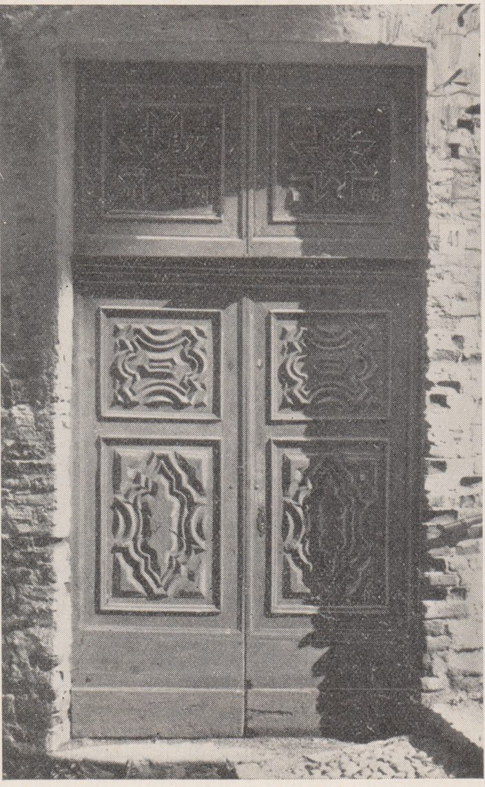

Biella, portale della chiesa chiesa di S. Lorenzo del Collegio dei Padri Somaschi,

**RELIGIOSI SOMASCHI**

**BIELLA**

**1706-1793**

**Mestre 29.4.2017**

**1706**

|  |  |  |  |
| --- | --- | --- | --- |
| *P. Riva Carlo*  *Atti Lugano* |  | *4.2.1706* | *Da Lugano* |

**1710**

|  |  |  |  |
| --- | --- | --- | --- |
| *P. Riva Carl’Antonio*  *Atti Lugano* |  | *12.11.1710* | *Da Lugano* |

**1711**

|  |  |  |  |
| --- | --- | --- | --- |
| *P. Bassi Giuseppe*  *Atti Merate* |  | *5.11.1711* | *Da Merate* |

**1727**

|  |  |  |  |
| --- | --- | --- | --- |
| *P. Mariani Pietro Maria*  *Atti Lugano* |  | *20.9.1727* | *A Biella* |
| *P. Salomone Gius.Alberto*  *Atti Lugano* |  | *9.11.1727* | *A Lugano* |

**1734**

|  |  |  |  |
| --- | --- | --- | --- |
| *P. Mainardi Francesco*  *Atti S. Maiolo PV* |  | *2.7.1734* | *A S. Maiolo PV* |

**1742**

|  |  |  |  |
| --- | --- | --- | --- |
| *Fr. Bresciano Pietro*  *Atti S. Maiolo PV* | *A Biella* | *31.3.1742* | *+ 15.3.1742* |

**1751**

|  |  |  |  |
| --- | --- | --- | --- |
| *P. Charmet Giovanni*  *Atti Vercelli* | *Rettore* | *2.6.1751* | *Da Vercelli* |

**1754**

|  |  |  |  |
| --- | --- | --- | --- |
| *P. Chermes Giovanni*  *Atti S. Maiolo PV* |  | *27.6.1754* | *A S. Maiolo PV* |
| *Fr. Ferno Gaetano*  *Atti Vercelli* |  | *6.6.1754* | *Da Vercelli* |

**1760**

**1761**

|  |  |  |  |
| --- | --- | --- | --- |
| *P. Calderaia Michele*  *Atti Vercelli* | *( di Biella )* | *4.5.1761* |  |

**1762**

**1763**

**1764**

|  |  |  |  |
| --- | --- | --- | --- |
| *P. Mafezzoli Giambattista*  *Atti Merate* |  | *29.8.1764* | *Da Merate* |

**1765**

**1766**

|  |  |  |  |
| --- | --- | --- | --- |
| *P. Malacrida Luigi*  *Atti SMS MI* | *Predicazione* | *3.2.1766*  *19.2.1766* | *Da SM Segreta MI* |

**1767**

**1768**

**1769**

**1770**

**1788**

|  |  |  |  |
| --- | --- | --- | --- |
| *P. Serpenti*  *Atti salute* | *In Biella* | *8.6.1788* | *+ 8.6.1788* |

**1789**

**1790**

|  |  |  |  |
| --- | --- | --- | --- |
| *Fr. Granelli Giuseppe*  *Atti Vigevano* |  | *5.1.1790* | *A Vercelli* |

**1791**

**1792**

**1793**

|  |  |  |  |
| --- | --- | --- | --- |
| *Fr. Granelli Giuseppe*  *Atti vercelli* |  | *19.12.1793* | *Da Vercelli* |