**A cura di Padre Secondo Brunelli crs**

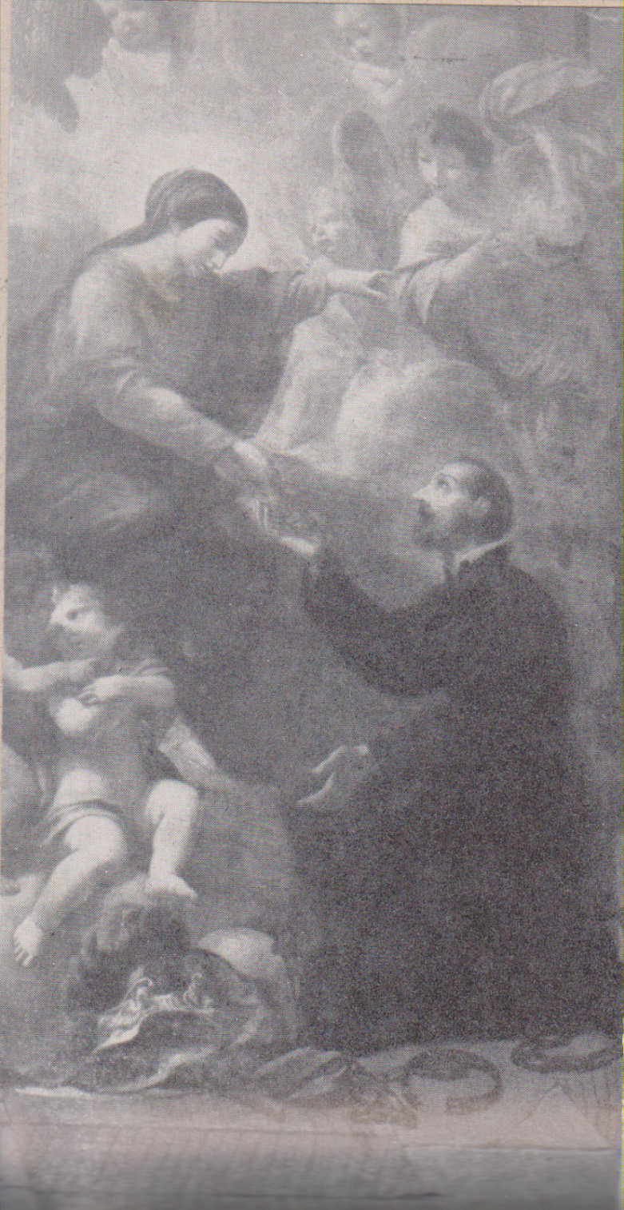

G. Antonio Cucchi (?), S. Girolamo Miani, San Venenzio di Camerino

**RELIGIOSI SOMASCHI**

**CAMERINO**

**1712-1804**

**Mestre 29.4.2017**

**1712**

|  |  |  |  |
| --- | --- | --- | --- |
| *P. Castaldi Carlo*  *Atti Velletri* |  | *26.12.1712* | *A Velletri* |
| *P. Centurione Giuseppe*  *Atti Velletri* |  | *5.7.1712* | *A Velletri* |

**1713**

|  |  |  |  |
| --- | --- | --- | --- |
| *P. Fiorini Nicola*  *Atti Velletri* |  | *21.3.1713*  *20.3.1713* | *Da Velletri* |

**1714**

|  |  |  |  |
| --- | --- | --- | --- |
| *P. Centurione Giuseppe*  *Atti Velletri* |  | *25.6.1714* | *Da Velletri* |

**1715**

|  |  |  |  |
| --- | --- | --- | --- |
| *P. Petrucci Filippo*  *Atti Velletri* |  | *30.6.1715* | *Da Velletri* |

**1716**

|  |  |  |  |
| --- | --- | --- | --- |
| *P. Centurione Giuseppe*  *Atti Salute* | *In Camerino* | *22.12.1716* | *+ 22.12.1716* |

**1720**

|  |  |  |  |
| --- | --- | --- | --- |
| *Fr. Giannelli Antonio*  *Atti Velletri* |  | *5.9.1720* | *Da Velletri* |
| *P. Rovereti Giuliano*  *Atti Velletri* |  | *30.10.1720* | *A Velletri* |

**1721**

|  |  |  |  |
| --- | --- | --- | --- |
| *P. Fiorini Nicola*  *Atti Velletri* |  | *22.12.1721* | *A Velletri* |

**1722**

|  |  |  |  |
| --- | --- | --- | --- |
| *P. Ravenna Ulderico*  *Atti Velletri* |  | *3.6.1722* | *Da Velletri* |

**1727**

|  |  |  |  |
| --- | --- | --- | --- |
| *P. Lanfranchi Bartolomeo*  *Atti Velletri* | *Maestro* | *15.6.1727* | *A Velletri* |

**1733**

|  |  |  |  |
| --- | --- | --- | --- |
| *P. Cevasco G. Battista*  *Atti Amelia* |  | *13.5.1733* | *Da Amelia* |
| *Fr. Mercanti Giacomo*  *Atti Salute* | *In Camerino* | *16.7.1733* | *+ 16.7.1733* |
| *P. Savini Pietro Francesco*  *Atti Amelia* | *Vicepreposito* | *13.5.1733* | *Da Amelia* |

**1734**

|  |  |  |  |
| --- | --- | --- | --- |
| *P. Barbati Gennaro*  *Atti Amelia* |  | *13.4.1734*  *4.6.1734* | *Ad Amelia* |
| *P. Tosi Nicolò*  *Atti Amelia* |  | *9.4.1734* | *Da Amelia* |

**1735**

|  |  |  |  |
| --- | --- | --- | --- |
| *Fr. Stefanoni Giuseppe*  *Atti Amelia* | *Ospite* | *19.4.1735* | *Da Amelia* |

**1736**

|  |  |  |  |
| --- | --- | --- | --- |
| *P. Randanini Niccolò*  *Atti Amelia* |  | *11.9.1736* | *Da Amelia* |

**1737**

|  |  |  |  |
| --- | --- | --- | --- |
| *Fr. Mazzola Tommaso*  *Atti S. Maiolo PV* | *A Camerino* | *4.1.1737* | ***+ 26.12.1736*** |

**1738**

|  |  |  |  |
| --- | --- | --- | --- |
| *Fr. Antonucci Gaetano*  *Atti Amelia* | *Ospite* | *18.1.1737* | *Da Amelia* |
| *P. Carpi Carlo*  *Atti S. Nicolò FE* |  | *12.7.1738* | *A S. Nicolò FE* |
| *Ch. Piacenti Raimondo*  *Atti S. Maiolo PV* |  | *11.5.1739* | *Da S. Maiolo PV* |

**1739**

|  |  |  |  |
| --- | --- | --- | --- |
| *P. Marchelli Giuseppe*  *Atti Velletri* |  | *6.5.1739* | *A Velletri* |
| *P. Romairone Franco*  *Atti Amelia* |  | *21.1.1739* | *Da Amelia* |

**1740**

|  |  |  |  |
| --- | --- | --- | --- |
| *Fr. Grillo G. Domenico*  *Atti Amelia* | *Ospite* | *31.5.1740* | *Da Amelia* |

**1741**

|  |  |  |  |
| --- | --- | --- | --- |
| *Fr. Grillo Giov. Domenico*  *Atti Amelia* |  | *14.9.1741* | *Ad Amelia* |

**1743**

|  |  |  |  |
| --- | --- | --- | --- |
| *Fr. Stefanoni Ambrogio*  *Atti Salute VE* | *In Camerino* | *1.11.1743* | *+ 1.11.1743* |
| *P Mazzanti Filippo*  *Atti Amelia* |  | *20.6.1743* | *Da Amelia* |

**1744**

|  |  |  |  |
| --- | --- | --- | --- |
| *P. Bossi Claudio Benigno*  *Atti S. Maiolo PV* |  | *8.9.1744* | *Da S. Maiolo PV* |
| *Fr. Natale Nicolò*  *Atti S. Maiolo PV* | *In Camerino* | *14.4.1744* | *+ 28.3.1744* |

**1745**

**1746**

|  |  |  |  |
| --- | --- | --- | --- |
| *Fr. Criacchetti Nicola*  *Atti Velletri* |  | *14.6.1746* | *A Velletri* |
| *Fr. Montellanico Tommaso*  *Atti Velletri* | *Accettazione* | *17.6.1746* | *Velletri* |

**1747**

|  |  |  |  |
| --- | --- | --- | --- |
| *P. Bossi Claudio Benigno*  *Atti Amelia* |  | *26.5.1747* | *Ad Amelia* |

**1748**

|  |  |  |  |
| --- | --- | --- | --- |
| *Fr. Palocci Feliciano*  *Atti S. Nicolò FE* |  | *5.6.1748* | *Da S. Nicolò FE* |

**1749**

|  |  |  |  |
| --- | --- | --- | --- |
| *P. Paganucci Francesco*  *Atti Amelia* |  | *31.7.1749* | *Ad Amelia* |

**1750**

|  |  |  |  |
| --- | --- | --- | --- |
| *Fr. Eusebi Francesco*  *Atti Salute Ve* | *In Camerino* | *6.2.1750* | *+ 6.2.1750* |

**1751**

**1752**

**1753**

|  |  |  |  |
| --- | --- | --- | --- |
| *P. Mozzanti Filippo*  *Atti S Nicolò FE* |  | *5.7.1753* | *A S. Nicolò FE* |

**1754**

**1755**

|  |  |  |  |
| --- | --- | --- | --- |
| *Fr. Magoncelli Lodovico*  *Atti Amelia* | *Ospite* | *22.7.1755* | *Ad Amelia* |
| *P. Sorrentini Tommaso*  *Atti Amelia* |  | *5.5.1755* | *Ad Amelia* |

**1756**

**1757**

|  |  |  |  |
| --- | --- | --- | --- |
| *Fr. Beccari Antonio*  *Atti S. Nicolò FE* |  | *2.2.1757* | *A S. Nicolò FE* |

**1758**

**1759**

**1760**

|  |  |  |  |
| --- | --- | --- | --- |
| *Fr. Fossati Giuseppe*  *Atti Velletri* | *Ospite* | *4.7.1760* | *Da Velletri* |

**1761**

|  |  |  |  |
| --- | --- | --- | --- |
| *P. Zendroni Giuseppe*  *Atti Amelia* |  | *29.10.1761* | *Ad Amelia* |

**1762**

|  |  |  |  |
| --- | --- | --- | --- |
| *D. Maderni Diego Franc.*  *Atti Merate* | *d* | *25.10.1762* | *Da Merate* |
| *P. Pini Ignazio*  *Atti Amelia* |  | *29.10.1762* | *Ad Amelia* |
| *D. Sardagna G. Battista*  *Atti Amelia* |  | *25.10.1762* | *Da Amelia* |

**1763**

|  |  |  |  |
| --- | --- | --- | --- |
| *P. Angeli Vincenzo Giov.*  *Atti S. Agost. TV* |  | *12.11.1763* | *A S. Agost. TV* |

**1764**

**1765**

|  |  |  |  |
| --- | --- | --- | --- |
| *Fr. Succhiarelli Giacomo*  *Atti Amelia* | *Ospite* | *9.8.1765*  *22.9.1765* | *Da Amelia* |

**1766**

|  |  |  |  |
| --- | --- | --- | --- |
| *P. Lasagna Girolamo*  *Atti Amelia* |  | *14.6.1766* | *Da Amelia* |

**1767**

|  |  |  |  |
| --- | --- | --- | --- |
| *P. Paganucci Francesco*  *Atti S. Nicolò FE* |  | *26.10.1767* | *Da S. Nicolò FE* |
| *P. Zucchi Giuseppe*  *Atti S. Nicolò FE* |  | *26.10.1767* | *Da S. Nicolò FE* |

**1768**

|  |  |  |  |
| --- | --- | --- | --- |
| *P. Ardia Gioachino*  *Atti S. Agost. TV* | *Maestro* | *10.6.1768* | *Da S. Agost. TV* |
| *P. Griseri Giov. Battista*  *Atti Velletri* |  | *27.5.1768* | *Da Velletri* |
| *P. Paganucci Francesco*  *Atti Salute VE* | *In Camerino* | *27.2.1768* | *+ 27.1.1768* |
| *P. Paganucci Francesco*  *Atti S. Maiolo PV* | *In Camerino,*  *49 anni* | *29.2.1768* | *+ 29.2.1768* |

**1769**

|  |  |  |  |
| --- | --- | --- | --- |
| *P. Giorgi Giuseppe*  *Atti Amelia* |  | *25.10.1769* | *Da Amelia* |
| *P. Selmi Domenico*  *Atti Amelia* |  | *6.7.1769*  *25.10.1769* | *Da Amelia*  *Ad Amelia* |
| *Fr. Succhiarelli Giacomo* |  | *29.10.1769*  *16.12.1769* | *Da Camerino* |
| *P. Zucchi Giuseppe*  *Atti Somasca* |  | *5.1.1769* | *A Smasca* |

**1770**

|  |  |  |  |
| --- | --- | --- | --- |
| *Fr. Palocci feliciano*  *Atti Salute* | *In Camerino* | *3.5.1770* | *+ 3.5.1770* |
| *P. Palocchi Feliciano*  *Atti S. Maiolo PV* | *In Camerino*  *80 anni* | *7.5.1770* | *+ 7.5.1770 circa* |

**1771**

**1772**

|  |  |  |  |
| --- | --- | --- | --- |
| *P. Griseri Giambattista*  *Atti Amelia* |  | *21.7.1772*  *26.8.1772*  *30.9.1772* | *Da Amelia* |
| *Fr. Sanmarco Nicola*  *Atti Amelia* |  | *21.7.1772* | *Da Amelia* |

**1773**

**1774**

**1775**

|  |  |  |  |
| --- | --- | --- | --- |
| *P. Griseri G.Battista*  *Atti Salute VE* | *In Camerino* | *30.7.1775* | *+ 30.7.1775* |
| *P. Griseri G. Battista*  *Atti S. Maiolo PV* | *In Camerino*  *49 anni* | *3.8.1775* | *+ 3.8.1775 circa* |

**1776**

**1777**

**1778**

**1779**

**1780**

|  |  |  |  |
| --- | --- | --- | --- |
| *P. Boldrini Domenico*  *Atti Amelia* |  | *1.7.1780* | *Da Amelia* |

**1781**

**1782**

**1783**

|  |  |  |  |
| --- | --- | --- | --- |
| *P. Ponfido cataldo*  *Atti Salute VE* | *In Camerino* | *15.7.1783* | *+ 15.7.1783* |

**1795**

|  |  |  |  |
| --- | --- | --- | --- |
| *P. Luini Giuseppe*  *Atti S. Maiolo PV* | *In Camerino* | *31.12.1795* | ***+ 29.5.1795*** |

**1804**

|  |  |  |  |
| --- | --- | --- | --- |
| *P. Aliprandi Francesco*  *Atti Clementino RM* |  | *15.3.1804* | *Da Clementino RM* |