**A cura di Padre Secondo Brunelli crs**

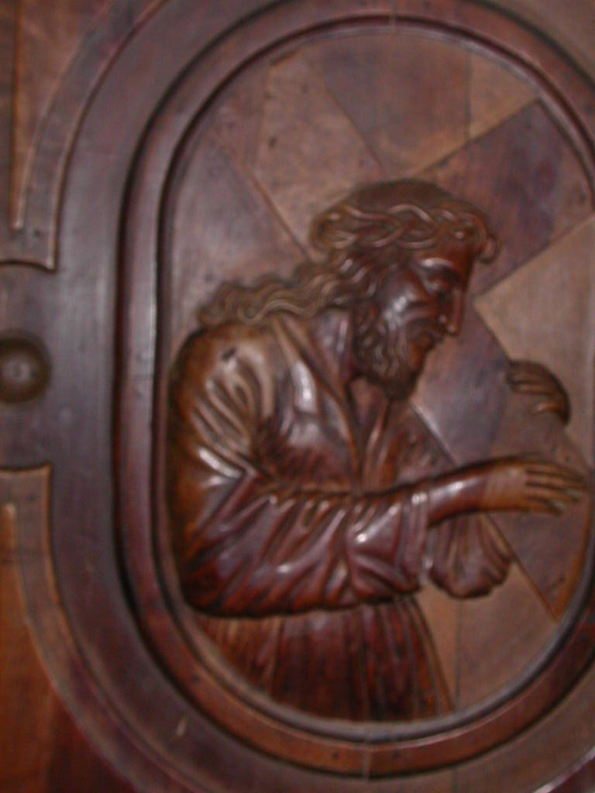

Gesù portacroce, Chiesa dei SS. Vittore Corona, Feltre

**MILANO COLOMBARA**

**RELIGIOSI SOMASCHI**

**1725-1767**

**Mestre 29.4.2017**

**Somascha, P. Gabriele Scotti, *Il pio luogo di Santo Spirito alla Colombara di Milano, nel secolo, XVI,* pag. *9-20***

**Auctores, p. Alcaini Giovanni 29-5**

**Milano, S. Croce di Triulzo e la Colombara: orfanotrofio per studenti, pag. 388, ms**

**L’8.5.1565 in Santa Croce di Trulzio si tiene il capitolo della Compagnia.**

**1565**

|  |  |  |  |
| --- | --- | --- | --- |
| P. Gambarana Angiolmarc |  | 8.5.1565 | Superiore |
| P. Giovanni di Valcamonica |  | 1565 |  |

**1578**

|  |  |  |  |
| --- | --- | --- | --- |
| *P. Manente Agostino* |  | *4.5.1578* |  |

**1591**

|  |  |  |  |
| --- | --- | --- | --- |
| *P. Tassoni Giorgio* |  | *1591* |  |

**1592**

|  |  |  |  |
| --- | --- | --- | --- |
| *P. Tassoni Giorgio* |  | *1592* |  |

**1593**

|  |  |  |  |
| --- | --- | --- | --- |
| **P. Tassoni Giorgio** |  | **1593** |  |

**Il 1.10.1594 alla Colombara presso Milano si tiene la dieta della Compagnia.**

**1594**

|  |  |  |  |
| --- | --- | --- | --- |
| P. Assaretto G.Battista |  | 1.10.1594 |  |
| Bragaccio Battista chierico | Accettato | 1.10.1594 |  |
| P. Bramicelli Guglielmo | Assente | 1.10.1594 |  |
| P. Brocco Bartolomeo |  | 1.10.1594 |  |
| P. Cimarelli Alessandro |  | 1.10.1594 |  |
| P. Croce Cristoforo |  | 1.10.1594 |  |
| P. Dorati Evangelista | Generale | 1.10.1594 |  |
| P. Fabreschi G.Battista | Assente | 1.10.1594 |  |
| P. Fornasari Battista | Consigliere | 1.10.1594 |  |
| P. Migliorini Luigi | Assente, Vicario | 1.10.1594 |  |
| Moltene Tommaso chier. | Accettato | 1.10.1594 | Vicentino |
| Montino Galeazzo chierico | Accettato | 1.10.1594 | Cremonese |
| Mossenese Filippo chier. | Accettato | 1.10.1594 | Milanee |
| P. Nardino Marcantonio | Assente | 1.10.1594 |  |
| P. Panevino Pantaleone | Nominato | 1.10.1594 |  |
| P. Paris Alessandro | Nominato | 1.10.1594 |  |
| Porcario Antonio laico | Accettato | 1.10.1594 | Romano |
| P. Saliverio Salustio | Nominato | 1.10.1594 |  |
| P. Stella Andrea | Nominato | 1.10.1594 |  |
| P. Tonso Guglielmo |  | 1.10.1594 |  |
| Trevisano Antonio chierico | Accettato | 1.10.1594 |  |
| Vanni Girolamo laico ospit | Accettato | 1.10.1594 | Di Viterbo |
| P. Veggiola Tommaso |  | 1.10.1594 |  |

**1594**

|  |  |  |  |
| --- | --- | --- | --- |
| *P. Tassoni Giorgio* |  | *1594* |  |

**1595**

|  |  |  |  |
| --- | --- | --- | --- |
| *Fr. Tacca Giovanni M.a* |  | *1595* |  |
| *P. Tassoni Giorgio* |  | *1595* |  |

**1596**

|  |  |  |  |
| --- | --- | --- | --- |
| *Fr. Tacca Giovanni M.a* |  | *1596* |  |
| *P. Tassoni Giorgio* |  | *1596* |  |

**1597**

|  |  |  |  |
| --- | --- | --- | --- |
| *P. Lombardi Marino* |  | *5.5.1597* |  |

**1608**

|  |  |  |  |
| --- | --- | --- | --- |
| *P. Gardone G. Pietro* |  | *1608* | *Da S. Geroldo CR* |

**1609**

|  |  |  |  |
| --- | --- | --- | --- |
| *P. Gardone G. Pietro* |  | *1609* | *Al Sem. Patr. VE* |

**1617**

|  |  |  |  |
| --- | --- | --- | --- |
| P. Porta G.Maria  Biog. 1030 | Rettore | 1617 |  |

**1618**

|  |  |  |  |
| --- | --- | --- | --- |
| P. Porta G.Maria | Rettore | 1618 |  |

**1619**

|  |  |  |  |
| --- | --- | --- | --- |
| P. Porta G.Maria | Rettore | 1619 |  |

**1620**

|  |  |  |  |
| --- | --- | --- | --- |
| P. Porta G.Maria | Rettore | 1620 |  |

**1621**

|  |  |  |  |
| --- | --- | --- | --- |
| P. Porta G.Maria | Rettore | 1621 |  |

**1622**

|  |  |  |  |
| --- | --- | --- | --- |
| P. Porta G.Maria | Rettore | 1622 |  |

**1623**

|  |  |  |  |
| --- | --- | --- | --- |
| P. Porta G.Maria | Rettore | 1623 |  |

**1624**

|  |  |  |  |
| --- | --- | --- | --- |
| P. Porta G.Maria | Rettore | 1624 |  |

**1625**

|  |  |  |  |
| --- | --- | --- | --- |
| P. Porta G.Maria | Rettore | 1625 |  |

**1626**

|  |  |  |  |
| --- | --- | --- | --- |
| P. Porta G.Maria | Rettore | 1626 |  |

**1627**

|  |  |  |  |
| --- | --- | --- | --- |
| P. Porta G.Maria | Rettore | 1627 |  |

**1628**

|  |  |  |  |
| --- | --- | --- | --- |
| P. Porta G.Maria | Rettore | 1628 |  |

**1629**

|  |  |  |  |
| --- | --- | --- | --- |
| P. Porta G.Maria | Rettore | Febb.1629 |  |

**1630**

|  |  |  |  |
| --- | --- | --- | --- |
| P. Porta G.Maria | Sua morte | **+ 1630** |  |

**I Somaschi, a cura di Migliorini, 1992, pag. 183-184,** ( sottolineato )

**1650**

|  |  |  |  |
| --- | --- | --- | --- |
| Fr. Minoia Lorenzo | Procuratore | 8.3.1650 |  |
| P. Terzaghi G.Battista | Vicerettore | 8.3.1650 |  |
| P. Valletta Carlo | Rettore | 8.3.1650 |  |

**1725**

|  |  |  |  |
| --- | --- | --- | --- |
| *P. Bossi Marcanton*  *Atti Merate* |  | *2.7.1725* | *A Merate* |
| *P. Strazza C. Giuseppe*  *Atti Somasca* |  | *19.5.1725* | *Da Somasca* |

**1728**

|  |  |  |  |
| --- | --- | --- | --- |
| *P. Strazza Carlo Giuseppe*  *Atti Somasca* |  | *29.10.1728* | *A Somasca* |

**1735**

|  |  |  |  |
| --- | --- | --- | --- |
| *P. Berretta G. Antonio (1)* |  | *5.1.1735* | ***+ 5.1.1735*** |

*(1) cfr. Riv. Congr. fasc. 1, 1925, P. Berretta Giovanni Antonio, pag. 19*

**1752**

|  |  |  |  |
| --- | --- | --- | --- |
| *P. Vailati Carlo Maria*  *Atti Vercelli* |  | *20.5.1752* | *Da Vercelli* |

**1754**

|  |  |  |  |
| --- | --- | --- | --- |
| *P. Vailati Carlo*  *Atti Salute* | *In Colombara MI* | *20.4.1754* | *+ 20.4.1754* |

**1755**

**1756**

|  |  |  |  |
| --- | --- | --- | --- |
| *P. Boldrini Giuseppe*  *ASMS MI* | *In Colombara* | *25.10.1756* |  |

**1759**

|  |  |  |  |
| --- | --- | --- | --- |
| *P. Assandri Ignazio*  *Atti SMS MI* | *Della Colombara MI* | *25.10.17539* |  |

**1762**

|  |  |  |  |
| --- | --- | --- | --- |
| *Fr. Onorio Dante Enr.*  *Atti SMS MI* |  | *26.9.1762* | *Da SM Segreta MI* |

**1763**

|  |  |  |  |
| --- | --- | --- | --- |
| *P. Azzimonti Ambrogio*  *Atti SMS MI* |  | *8.10.1763* | *Da SM Segreta MI* |

**1764**

**1765**

|  |  |  |  |
| --- | --- | --- | --- |
| *P. Azzimonti Ambrogio*  *Atti SMS MI* | *Colombara MI* | *25.10.1765* |  |

**1785 la Colombara cessa di esistere.**