**A cura di padre Secondo Brunelli crs**

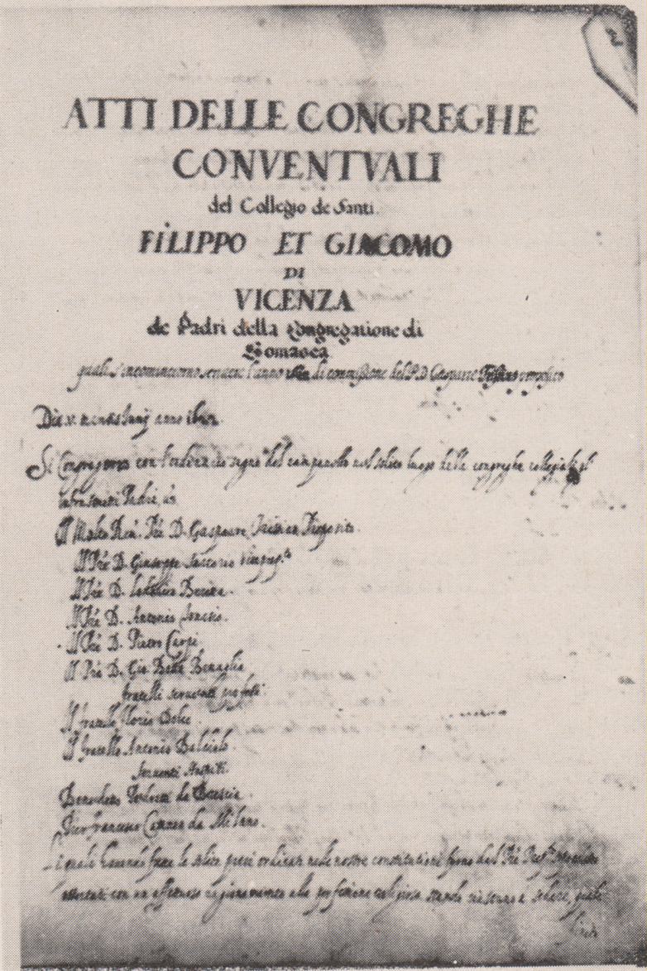

**RELIGIOSI SOMASCHI**

**AI SANTI FILIPPO E GIACOMO**

**1583-1700**

**Mestre 29.4.2017**

**Riv. Congr., fasc. 25, pag. 8-43, di Sebastiano Rumor, *La chiesa ed il convento dei Padri Somaschi a Vicenza.***

***I dati saranno contrassegnati da \****

**Riv. Congr., fasc, 123, 1957, P. Marco Tentorio, *Mons. Francesco Bembo, crs superiore dei Padri Somaschi nella casa dei SS. Filippo e Giacomo a Vicenza*, pag. 160-165.**

**Riv. Congr., fasc. 124, 1958, P. Marco Tentorio, *Mons. Francesco Bembo crs superiore dei Padri Somaschi nella casa dei SS. Filippo e Giacomo a Vicenza, pag. 27-32.***

**Riv. Congr., fasc. 30, 1929, pag. 376-382, P. Angelo Stoppiglia, *III. Vicenza, Collegio dei Santi ilippo e Gacomo.***

***I dati saranno contrassegnati da \****

**1572**

|  |  |  |  |
| --- | --- | --- | --- |
| *Ch. Migliorini Luigi\** | *Professione* | *1572* |  |

**1574**

|  |  |  |  |
| --- | --- | --- | --- |
| *Ch. Novelli Girolamo\** | *Professione* | *1574* |  |

**I Padri Somaschi 0sno chiamati ai Santi Filippo e Giacomo nel 1583**

**1583**

|  |  |  |  |
| --- | --- | --- | --- |
| P. Cimarelli Alessandro |  | 1583  10.8.1583 | Da Genova |

**1584**

|  |  |  |  |
| --- | --- | --- | --- |
| *Ch. Basso Giuseppe* | *Noviziato* | *1584* |  |

**1585**

|  |  |  |  |  |
| --- | --- | --- | --- | --- |
| *Ch. Basso Giuseppe\** | | *Professione* | *12.8.1585* |  |
| *P.Fabresco* | |  | *12.8.1585* |  |
| *Ch. Micheli G.Domen\** | *Professione* | *1585* |  | |

**1586**

**1587**

|  |  |  |  |
| --- | --- | --- | --- |
| P. Fornasari G. Battista | Preposito | 26.8.1587 |  |

**1588**

|  |  |  |  |
| --- | --- | --- | --- |
| *Ch. Sartorio Giuseppe\** | *professione* | *1588* | ***+ 1656*** |

**1589**

|  |  |  |  |  |  |  |  |
| --- | --- | --- | --- | --- | --- | --- | --- |
| |  |  |  |  | | --- | --- | --- | --- | | *Ch. Rossetti Francesco\** | *Professione* |  |  | | *Professione* | *1589* |  |

**1590**

|  |  |  |  |
| --- | --- | --- | --- |
| *Ch. Porto Luigi\** | *Professione* | *1590* |  |

**1591**

**1592**

**1593**

**1594**

**1595**

**1596**

|  |  |  |  |
| --- | --- | --- | --- |
| *Ch. Malloni Tommaso\** | *Professione* | *1596* |  |

**1597**

**1597**

**1598**

**1599**

|  |  |  |  |
| --- | --- | --- | --- |
| *P. Calta Giovanni* | *Professione* | *1599* |  |

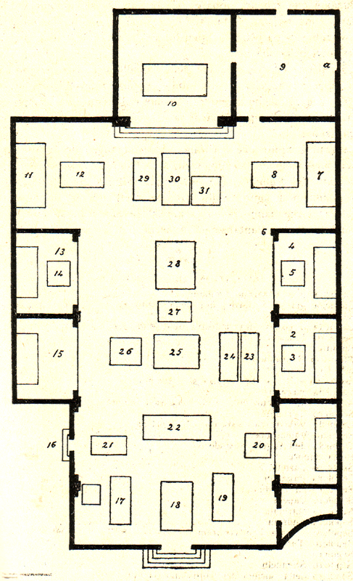

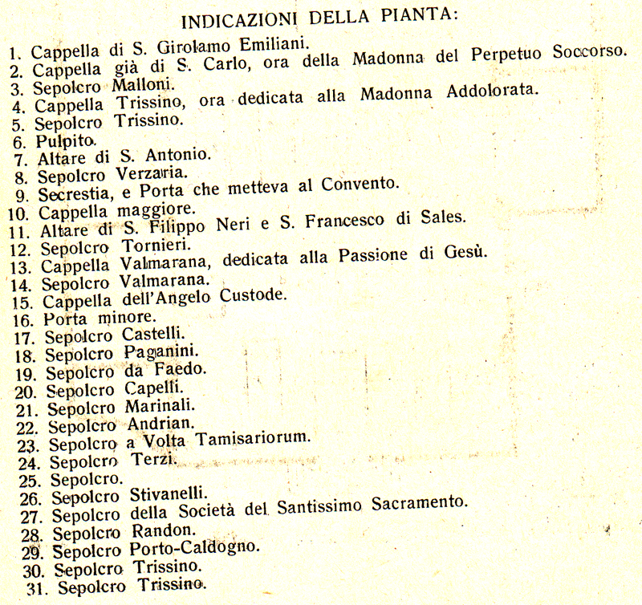

**Nel 1600 da piccola casa accanto alla chiesa si spostarono nella sede attuale.**

**1600**

|  |  |  |  |
| --- | --- | --- | --- |
| P. Porto ??? |  | 7.1.1600 |  |
| P. Stella Andrea | Preposito  Procuratore | 1600  27.10.1600 |  |
| *** |  |  |  |
| P. Terzano Andrea | Generale | 27.10.1600 |  |

**1601**

|  |  |  |  |  |
| --- | --- | --- | --- | --- |
| P. Antonio |  | 1.6.1601 | |  |
| P. Cremaschi Andrea |  | 1.6.1601 | |  |
| Fr. Intriviso Natale |  | 1.6.1601 | |  |
| Fr. Solino Marcantonio |  | | 1.6.1601 |  |
| P. Stella Andrea | Preposito | | 1.6.1601 |  |
| P Tagliapietra Alvise |  | | 10.1.1601  10.7.1601 |  |
| *** |  | |  |  |
| P. Assareto G. Battista | Generale | | 10.5.1601 |  |
| P. Tinti Girolamo | Rettore Misercor. | | 2.6.1601 |  |

**1602**

|  |  |  |  |
| --- | --- | --- | --- |
| P. Stella Andrea | Preposito | 24.6.1602  16.12.1602 | In Dalmazia |
| P. Tagliapietra Alvise |  | 11.1.1602 |  |

**1603**

|  |  |  |  |
| --- | --- | --- | --- |
| *P. De Domis Mauzizio.* |  | *1603* | *Da SM. Segreta MI* |
| *Ch. Dal Toso Andrea\** | *professione* | *1603* |  |
| *** |  |  |  |
| P. Ganna Biagio | In Venezia | 15.1.1603 |  |

**1604**

|  |  |  |  |
| --- | --- | --- | --- |
| *Ch. Trissino Gaspare*  *Elogia* | *Professione* | *7.9.1604* |  |
| *Ch. Rinaldi Silvestro* |  | *1604* | + 1604 |

**Causa l’interdetto i Padri riparano quasi tutti nel milanese.**

**1605**

|  |  |  |  |
| --- | --- | --- | --- |
| P. Anguisciola Alvise | Preposito | 1605 |  |

**1606**

|  |  |  |  |
| --- | --- | --- | --- |
| *P. Carpio Pietro\** | *Professione* | *1606* |  |

**1607**

|  |  |  |  |  |  |
| --- | --- | --- | --- | --- | --- |
| *P. Cordellina G.Battista\** | *Professione* | *1606* | |  | |
| *Ch. Garzadori Andrea* | *Professione* | *1607* | |  | |
| *Ch. Marchiano Bortolo\** | *Professione* | | *1606* | |  | |

**1608**

|  |  |  |  |
| --- | --- | --- | --- |
| *P. Delio Vittorio\** | *Professione* | *1608* |  |
| *P. Benaglia G. Battista (1)* | *63 anni* | *22.3.1608* | ***+ 22.3.1608*** |
| *Ch. Martelli Paolo\** | *Professione* | *1608* |  |
| *Ch. Moro Evangelista* | *Noviziato* | *1608* |  |
| *Ch. Muzio Andrea\** | *Professione* | *1608* |  |
| P. Stella Andrea | Preposito | 14.1.1608 |  |
| *** |  |  |  |
| P. Fabbreschi G. Battista | Proc. Generale | 9.6.1608 |  |
| P. Ganna Biagio | Rettore Semin. VI | 14.1.1608 |  |

*(1) Riv. Congr., fasc. 30, 1929, P.Benaglia Giovanni Battista, pag. 388-390*

**1609**

|  |  |  |  |
| --- | --- | --- | --- |
| *Ch. Moro Evangelista\** | *Professione* | *1609* |  |
| *Ch. Moro Orazio* | *Noviziato* | *1609* |  |

**1610**

|  |  |  |  |
| --- | --- | --- | --- |
| *Ch. Moro Orazio\**  *Riv. Congr.* | *Professione* | *25.7.1610* |  |
| *P. Zoia* |  | *25.7.1610* |  |

**1611**

|  |  |  |  |
| --- | --- | --- | --- |
| *P. Caldogno Domenico\** | *Professione* | *1611* |  |
| *Ch. Marchi Marcantonio*  *Elogia* | *Professione* | *8.9.1611* |  |
| *Fr. Meloni Giovanni*  *Processi* | *Testimone* | *7.8.1611* |  |
| *Ch. Rabesani Vincenzo\** | *Professione* | *1611* |  |
| *P. Zoia Francesco*  *Processi* | *Preposito* | *7.8.1611* |  |

**1612**

|  |  |  |  |
| --- | --- | --- | --- |
| *Ch. Torre Pietro\** | *Professione* | *1612* |  |
| *Ch. Valmarana Girolamo\** | *Professsione* | *28.8.1612* |  |

**1613**

**1614**

|  |  |  |  |
| --- | --- | --- | --- |
| P. Cornalba Desiderio | Preposito | 12.5.1614 |  |
| *** |  |  |  |
| P. Corsoio Evangelista | Rettore Salute VE | 12.5.1614 |  |

**1615**

**1616**

**1617**

|  |  |  |  |
| --- | --- | --- | --- |
| *P. Cerchiari Bartolomeo\** | *Professione* | *1617* |  |

**1618**

|  |  |  |  |
| --- | --- | --- | --- |
| *P. P. Cerchiari Luigi\** | *Professione* | *1618* |  |

**1619**

**1620**

**1621**

**1622**

**1623**

|  |  |  |  |
| --- | --- | --- | --- |
| *Ch. Piovene P.Paolo\** | *Professione* | *1623* |  |

**1624**

|  |  |  |  |
| --- | --- | --- | --- |
| *P. Moro Orazio*  *Atti Salò* | *28 anni* | *2.4.1624* | ***+ 31.3.1624*** |

**1625**

**1626**

**1627**

|  |  |  |  |
| --- | --- | --- | --- |
| *Ch. Segala Giovanni* | *Noviziato* | *16278* |  |
| *Ch. Valmarana Floriano\** | *Professione* | *1627* | ***+ 1650*** |

**1628**

|  |  |  |  |
| --- | --- | --- | --- |
| *Ch. Segala Giovanni*  *Riv. Congr.* | *Professione* | *2.4.1628* |  |
| *P. Trissino* |  | *2.4.1628* |  |

**1629**

**1630**

|  |  |  |  |
| --- | --- | --- | --- |
| *Ch. Rossi Carlo* | *Professione* | *6.6.1630* | ***+ feb. 1671*** |
| *P. Trissino* |  | *6.6.1630* |  |

**1631**

**1632**

**1633**

**1634**

|  |  |  |  |
| --- | --- | --- | --- |
| *P. Frighelli Davide\** | *Professione* | *1634* |  |

**1635**

**1636**

|  |  |  |  |
| --- | --- | --- | --- |
| *P. Beretta Antonio\** | *Professione* | *1636* |  |

**1637**

**1638**

**1639**

**1640**

**1641**

|  |  |  |  |
| --- | --- | --- | --- |
| P. Marchi Marcantonio |  | 1641 |  |
| P. Sartorio Giuseppe |  | 1641 |  |
| *** |  |  |  |
| P. Carrara Paolo | Vicario Generale | 1641 |  |
| P. Priuli G. Francesco |  | 1641 |  |
| P. Varese Ambrogio | Generale | 1641 |  |

**1642**

|  |  |  |  |  |  |  |
| --- | --- | --- | --- | --- | --- | --- |
| P. Marchi Marcantonio | |  | | 17.2.1642 |  | |
| *Ch. Sala Michelangelo\** | | *Professione* | | *1642* | ***+ 1663*** | |
| *** |  | |  | | |  |
| P. Carrara Paolo | Vicario Generale | | 1642 | | |  |
| P. Moro Pietro | Rett.Mendicanti VE | | 1642 | | |  |
| P. Priuli G. Francesco |  | | 1642 | | |  |

**1643**

**1644**

**1645**

**Nel 1646, a Vicenza, P. Longo Lorenzo pubblica il poemetto *Lituus Belli Sacri contra Turcas.***

**Nel 1646, a Vicenza. P. Longo Lorenzo pubblica *Ars vincendi hostes, necnon Stratagemma sacrum cum commentariis***

**1646**

**1647**

**1648**

**1649**

|  |  |  |  |
| --- | --- | --- | --- |
| P. Benaglia G. Battista | Curato | 17.10.1649 |  |

**I Somaschi, a cura di Migliorini, 1992, pag. 154-156, ( sottolineato )**

**1650**

|  |  |  |  |
| --- | --- | --- | --- |
| P. Benaglia G. Battista | Curato | 19.8.1650 |  |
| P. Caldogno Domenico |  | 19.8.1650 |  |
| P. Cerchiari Bartolomeo | Viceprep.to | 19.8.1650 |  |
| P. Clerici Tommaso |  | 19.8.1650 |  |
| P. Cardellina G.Battista |  | 19.8.1650 |  |
| Fr. Glisenti Antonio |  | 19.8.1650 |  |
| P. Guberni Antonio |  | 19.8.1650 |  |
| P. Morando Alessandro |  | 19.8.1650 |  |
| *Ch. Priante G.Battista* | *Professione* | *27.12.1650* |  |
| Fr. Ronco Gaspare |  | 19.8.1650 |  |
| *P. Riva Antonio\** |  |  |  |
| Fr. Rossi Benedett |  | 19.8.1650 |  |
| P. Valmarana Floriano |  | 19.8.1650 |  |
| P. Vimercato Ferrante |  | 19.8.1650 |  |

**1651**

|  |  |  |  |
| --- | --- | --- | --- |
| *P. Benaglia G. Battista\** | *Curato* | *Presente* |  |

**1652**

|  |  |  |  |  |
| --- | --- | --- | --- | --- |
| *P. Benaglia G. Battista\** | *Curato* | *Presente* |  | |
| P. Cerchiari Bartolomeo | Vicepreposito | 7.3.1652 | |  |
| P. Priuli Girolamo | Preposito | 7.3.1652 | |  |
| P. Ricco Giuseppe Senior |  | 7.3.1652 | |  |
| P. Rutta G. Francesco | Commissario (?) | 7.3.1652 | |  |

**1653**

|  |  |  |  |
| --- | --- | --- | --- |
| *P. Benaglia G. Battista\** | *Curato* | *Presente* |  |
| *P. Patusio Bernardino* | *Socio* | *1653* |  |

**1654**

|  |  |  |  |  |
| --- | --- | --- | --- | --- |
| *P. Benaglia G. Battista*(1)* | *Curato* | | *Presente* |  |
| *P. Sartorio Giacomo* |  | *15.3.1654* | | ***+ 15.3.1654*** |

*(1) Riv. Congr., fasc. 30, 1929, P. benaglia Giovanni Battista, pag. 390-391*

**1655**

**1656**

**1657**

**1658**

**1559**

**1660**

**1661**

**1662**

|  |  |  |  |
| --- | --- | --- | --- |
| *** |  |  |  |
| P. Marchi Marcantonio | Rett. Miseric. VI | 28.6.1662 |  |

**1663**

|  |  |  |  |
| --- | --- | --- | --- |
| P. Cerchari Bartolomeo |  | 2.10.1663  2.12.1663 |  |
| P. Marchi Marcantonio | *Da Misericordia VI* | 5.10.1663 | *Da Misericordia VI* |
| *** |  |  |  |
| P. Ferrigelli David |  | 5.10.166 |  |
| P. Ronzoni | Provinciale | 5.10.166 |  |

**1664**

|  |  |  |  |
| --- | --- | --- | --- |
| P. Fumarelli Antonio | Attuario | 16.10.1664 |  |
| P. Marchi Marcantonio | Preposito | 29.3.1664  19.4.1664  23.4.1664  28.5.1664  2.6.1664  10.6.1664  16.7.1664  14.8.1664  27.8.1664  4.9.1664  29.9.1664  19.10.1664  21.10.1664  2.11.1664  10.11.1664  19.11.1664  2.12.1664 |  |
| P. Priuli Girolamo | Rettore | 16.10.1664 |  |
| *** |  |  |  |
| P. Buffa | Rettore | 29.9.1664  19.10.1664  2.11.1664 |  |
| P. Danieli | Preposito | 16.7.1664  19.11.1664 |  |
| P. Ferrari | Rettore | 4.9.1664  10.11.1664 |  |
| P. Fanzago | Rettore | 10.6.1664  14.8.1664 |  |
| P. Ferrari | Rettore | 4.9.1664  10.11.1664 |  |
| P. Ferrigelli David |  | 23.4.1664  14.8.1664  21.10.1664 |  |
| P. Passi | Consigliere | 16.7.1664  19.11.1664 |  |
| P. Priante G. Battista |  | 29.9.1664 |  |
| P. Rossi | Generale | 29.3.1664  23.4.1664  28.5.1664 |  |
| P. Rossi Carlo |  | 29.3.1664  29.9.1664 |  |
| P. Rotta Stefano |  | 29.9.1664 |  |
| P. Segala | Rettore | 2.12.1664 |  |
| P. Valmarana | Già deceduto | 2.6.1664  27.8.1664  2.12.1664 |  |
| P. Zanchi | Rettore | 10.6.1664 |  |

**1665**

|  |  |  |  |
| --- | --- | --- | --- |
| *Ch. Dal Toso Camillo\** | *Professione* | *1665* |  |

|  |  |  |  |
| --- | --- | --- | --- |
| P. Marchi Marcantonio | Preposito | 6.2.1665  8.3.1665  15.3.1665  23.3.1665  9.4.1665  30.4.1665  5.6.1665 |  |
| *P. Orgiano Alvise*  *Elogia* | *Professione 24.6.1665* |  |  |
| *** |  |  |  |
| P. Ferrigelli David |  | 8.3.1665 |  |
| P. Gambarana | Già deceduto | 9.4.1665 |  |
| P. Priuli Girolamo | Definitore | 15.3.1665  9.4.1665 |  |
| P. Rossi Carlo |  | 6.2.1665 |  |
| P. Tunesi | Rettore | 23.3.1665 |  |
| P. Segala | Rettore | 30.4.1665 |  |

**1666**

|  |  |  |  |
| --- | --- | --- | --- |
| P. Rossi Carlo |  | Presente |  |

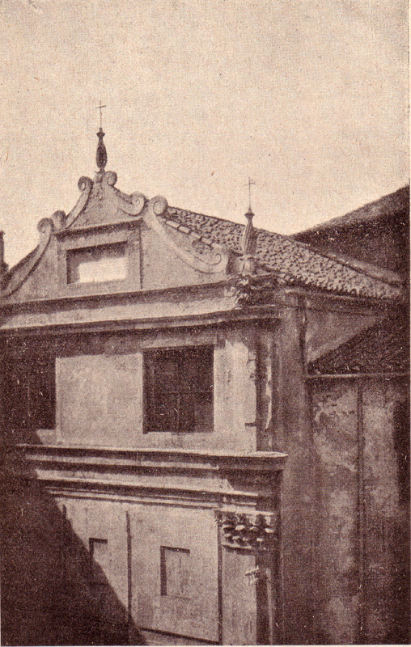

**Vicenza, chiesa di San Giacomo**

**1667**

|  |  |  |  |
| --- | --- | --- | --- |
| P. Marchi Marcantonio | Preposito | 10.5.1667 |  |
|  |  |  |  |
| *Ch. Piovene Camillo\** | *Professione* | *1667* | ***+1720*** |
| *P. Rossi Carlo* |  | *Presente* |  |

**CRS 0167**

**Facoltà di trasferire il noviziato da Roma a Napoli, e lo studentato da Salò a Vicenza, 25 luglio 1668.**

**1668/07**

**1668**

|  |  |  |  |
| --- | --- | --- | --- |
| P. Gavellis | Preposito | 15.1.1668 |  |
| |  |  |  |  | | --- | --- | --- | --- | | *Ch. Piovene G.Battista\** | *Professione* |  |  | | *Professione* | *1668* | ***+ 1727*** |
| *P. Rossi Carlo* |  | *Presente* |  |

**1669**

|  |  |  |  |  |  |  |  |
| --- | --- | --- | --- | --- | --- | --- | --- |
| |  |  |  |  | | --- | --- | --- | --- | | *Ch. Porto Giuseppe\** | *Professione* |  |  | | *Professione* | *1669* | ***+ 1683*** |
| P. Rosa Pietro Paolo | Maestro, Predicat. | Feb. 1669 |  |
| *P. Rossi Carlo* |  | *Presente* |  |

**CRS 0179**

**Mutatio professorii da Vicenza alla Salute di Venezia, 10 luglio 1670.**

**1670/07/10**

**1670**

|  |  |  |  |
| --- | --- | --- | --- |
| *P. Rossi Carlo* |  | *Presente* |  |
| P. Segala M. Giuseppe | Preposito | 23.11.1670 |  |
| Fr. Tressino Alessandro | Professione | 23.11.1670 | ***+ 1704*** |

**1671**

|  |  |  |  |
| --- | --- | --- | --- |
| Ch. Avoldi Francesco | Professione | 7.4.1671 |  |
| *P. Rossi Carlo (1)* |  | *Feb. 1671* | ***+ Feb. 1671*** |
| P. Segala M. Giuseppe | Preposito | 7.4.1671  26.4.1671  2.5.1671 |  |
| Ch. Toso Matteo | Vestizione | 7.4.1671 |  |
| *** |  |  |  |
| P. Cosmi | Provinciale | 2.5.1671 |  |
| P. Galliani Girolamo | Generale | 7.4.1671 |  |

*(1), Riv. Congr., fasc. 18, 1927, P. Rossi Carlo, pag. 272*

**1672**

**1673**

**1673**

|  |  |  |  |
| --- | --- | --- | --- |
| *Ch. Trissimo G.Battista\** | *Professione* | *1674* |  |

**1674**

**1675**

|  |  |  |  |  |  |  |  |
| --- | --- | --- | --- | --- | --- | --- | --- |
| |  |  |  |  | | --- | --- | --- | --- | | *Ch. Palazzi Cattarino\** | *Professione* |  |  | | *Professione* | *1675* | ***+ In VE 1708*** |
| |  |  |  |  | | --- | --- | --- | --- | | *Ch. Porto Antonio\** | *Professione* |  |  | | *Professione* | *1675* | ***+ 1.12.1740,*** *84an.* |

**1676**

|  |  |  |  |
| --- | --- | --- | --- |
| *P. Dal Toso Luigi\** | *Professione* | *1676* |  |

**1677**

**1678**

|  |  |  |  |
| --- | --- | --- | --- |
| *P. Ferretti P.Francesco\** | *Professione* | *1678* |  |

**1679**

|  |  |  |  |
| --- | --- | --- | --- |
| *P. Conti Bartolomeo\** | *Professione* | *1679* |  |
| *P. Cerchiari Bartolomeo* | *In VI? A 79 anni* | *2.1.1679* | ***+ 2.1.1679*** |
| P. Marchi Marcantonio | Preposito | 2.2.1679 |  |
| *Ch. Pagello Alessandro\** | *Professione, 78 anni* | *1679* | ***+ 16.3.1735*** |
| *** |  |  |  |
| P. Cosmi Stefano |  | 2.2.1679 |  |
|  |  |  |  |

**1680**

**1681**

|  |  |  |  |
| --- | --- | --- | --- |
| *P. Darella Andrea\** | *Professione* | *1681* |  |
| *Ch. Perpenti Francesco\** | *Professione* | *1681* | ***+ 20.4.1738*** *77 ann.* |

**1682**

|  |  |  |  |
| --- | --- | --- | --- |
| *P. De Marchis Marcantonio* |  | *1682* | ***+ 1682*** |

**1683**

**1684**

|  |  |  |  |
| --- | --- | --- | --- |
| *P. De Lugo Luigi\** | *Professione* | *1684* |  |
| *Ch. Porto M.Antonio \** | *Professione* | *1684* | ***+ 28.12.1731*** *64 an.* |
| *P.Priante* |  | *10.4.1684* |  |
| *Ch. Schio Basilio\** | *Professione* | *10.4.1684* |  |

**1685**

**1686**

|  |  |  |  |
| --- | --- | --- | --- |
| *P. Thiene Camillo*  *Atti Misericordia VI* | *Preposito* | *4.8.1686* |  |

**1687**

|  |  |  |  |
| --- | --- | --- | --- |
| *P. Laghi G. Battista (1) Riv. Congr.* | *In Seminario* | *1687* |  |

**1688**

|  |  |  |  |
| --- | --- | --- | --- |
| *P. Laghi G. Battista (1)* | *In Seminario* | *1688* |  |

**1689**

|  |  |  |  |  |  |  |  |
| --- | --- | --- | --- | --- | --- | --- | --- |
| *Ch. Cosmantonio Feder.\** | | *Professione* | *1689* | |  | | |
| *P. Laghi G. Battista (1)* | | *In Seminario* | | | *1689* | |  |

**1690**

|  |  |  |  |
| --- | --- | --- | --- |
| *P. Laghi G. Battista (1)* | *In Seminario* | *1690* |  |
| *D. Paccata Taddeo* |  | *1690* | *Da Sam Duc* |

**1691**

|  |  |  |  |
| --- | --- | --- | --- |
| *P. Laghi G. Battista (1)* | *In Seminario* | *1691* |  |
| *D. Paccata Taddeo* |  | *1691* | *A Se Patr. VE* |

**1692**

|  |  |  |  |
| --- | --- | --- | --- |
| P. Bembo G. Francesco | Preposito | 15.4.1692 |  |
| *Ch. Trissino Baldovino\** | *Professione* | *1692* |  |

**CRS 0270 m 2**

**Mutatio novitiatus da Venezia a Vicenza, 7 settembre 1693.**

**1693/09/07**

**1693**

**1694**

|  |  |  |  |
| --- | --- | --- | --- |
| *P. Laghi G.Battista*  *Riv. Congr.* | *Rett. In Seminario VI* | *1694* | *Da Salute VE* |
| *Ch. Monari Angelico\** | *Professione* | *1694* |  |

|  |  |  |  |
| --- | --- | --- | --- |
| *** |  |  |  |
| Mons. Bembo |  | Marzo 1694 |  |
| P. Cristoforo Pier Paolo | Vicerettore a TN | Dic. 1694 |  |

**1695**

|  |  |  |  |
| --- | --- | --- | --- |
| *P. Capello Gaet. Gott.do\** | *Professione* | *1695* |  |
| *P. Laghi G.Battista* | *Rett. In Seminario VI* | *1695* |  |
| *** |  |  |  |
| P. Cristoforo Pier Paolo | Vicerettore a TN | Genn. 1665 |  |

**1696**

|  |  |  |  |
| --- | --- | --- | --- |
| P. Gottardi Pietro Paolo | Predicatore | Aprile 1696 |  |
| *P. Laghi G.Battista* | *Rett. In Seminario VI* | *1696* |  |
| *Ch. Pagello Alessandro* | *Noviziato* | *1696* |  |
| P. Rosa |  | 27.5.1696 |  |
| *** |  |  |  |
| P. Sormani | Generale - quadro | Apr. 1696 |  |

**1697**

|  |  |  |  |  |
| --- | --- | --- | --- | --- |
| *P. Laghi G.Battista* | *Rett. In Seminario VI* | *1697* |  | |
| *Ch. Pagello Alessandro*  *Riv. Congr.* | *Professione* | *10.7.1697* |  | |
| P. Porto Antonio | Preposito | 26.5.1697 |  | |
| *P. Zorzi* |  | *10.7.1697* |  | |
| *** |  |  | |  |
| *P. Sarvetti Ferd. Carlo*  *Atti Miserixordia VI* | *Predicatore* | *Febbr. 1697* | |  |

**1698**

|  |  |  |  |
| --- | --- | --- | --- |
| *P. Laghi G.Battista* | *Rett. In Seminario VI* | *1698* |  |

**1699**

|  |  |  |  |
| --- | --- | --- | --- |
| *P. Laghi G.Battista* | *Rett. In Seminario VI* | *1699* |  |

**1700**

|  |  |  |  |
| --- | --- | --- | --- |
| *P. Laghi G.Battista* | *Rett. In Seminario VI* | *1700* |  |